Andrew Rutherford

CSCI 4113

Homework 4

1. File \* | while read c1 c2; do echo $c2; done | uniq –c  
     
   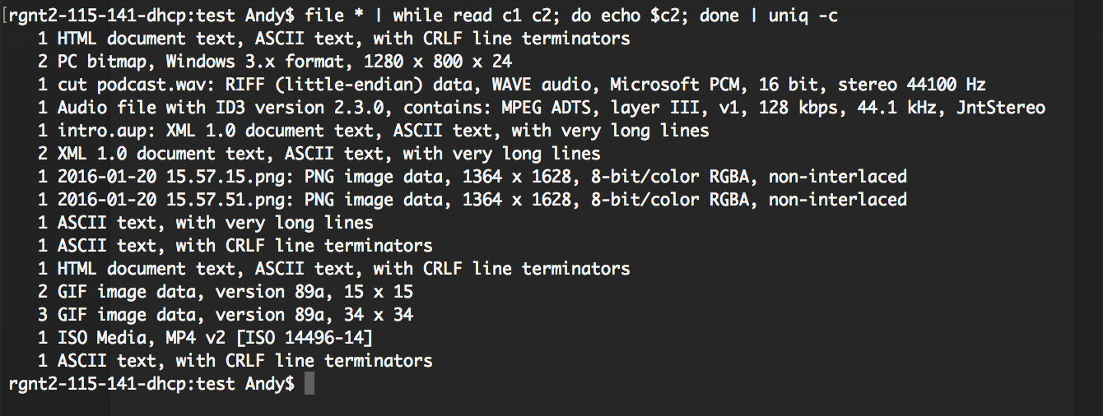
2. No muddy topics from last week.
3. Last shows a history of the last logged in users. This is useful when, in the case of something going terribly wrong, you can backtrack, and see a list of users that have most recently logged into that machine.